* [**How to modify the number of items displayed in a view**](https://sharepoint.rackspace.com/Learning/Articles/Pages/SharePoint-2013--how-to-modify-the-number-of-items-displayed-in-a-view.aspx)

Changing the number of items displayed in a view can be beneficial for several reasons.  If you have very large SharePoint lists and libraries, thousands of items, limiting the amount of items returned can increase performance and stability. More importantly, if you don’t create views on your SharePoint lists and libraries and you reach the 5,000 item list view threshold you will not enjoy fixing this issue.  For more information about managing large lists and libraries click [**here**](https://support.office.com/en-us/article/Manage-lists-and-libraries-with-many-items-b8588dae-9387-48c2-9248-c24122f07c59?ui=en-US&rs=en-US&ad=US). The article does a great job explaining the basics of list and libraries also, how to organize your content so you never run into those issues.  
  
1. From your SharePoint site, open any list or library you would like, in this example I will open my “Documents” library.  
  
2. At the top of the page click **LIBRARY** to expand the ribbon.

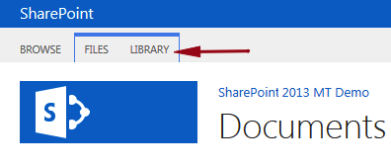

3. In the settings section click **Library Settings**.

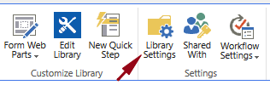

4. On the Document Settings page, scroll to the bottom and under the Views heading, click the view you would like to edit, in this example **All Documents**.

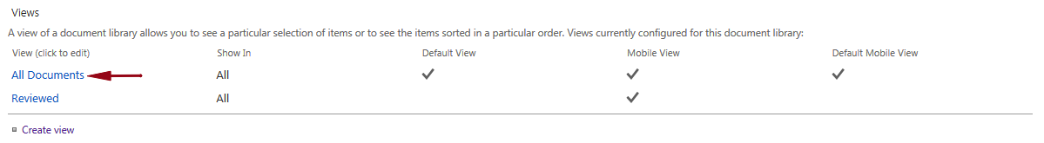

5. On the Edit View page scroll down and click **+ Item Limit**.

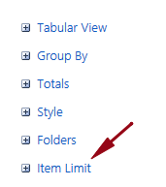

Just for this example so I can demonstrate how it works, I will change the Number of items to display to something smaller than you would ever want to set on a list or library.   
  
6. In the Number of items to display, type **10**.  
  
7. Click the radio button next to **Limit the total number of items returned to the specified amount**.

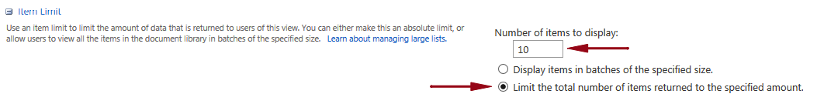

8. Scroll to the bottom and click **OK**.

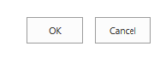

9. You can now see my view is only displaying the first 10 items.

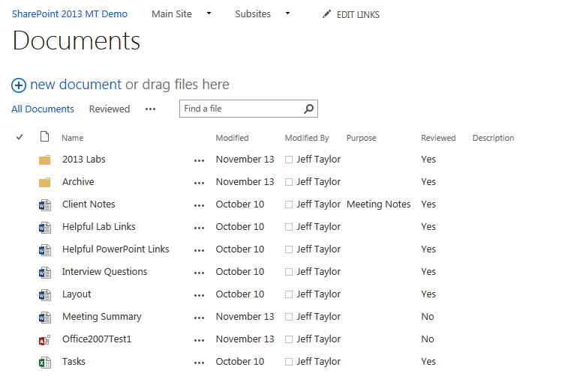

Keep in mind this is only for this view.  If I were to click on a different view within this list it will not have the same 10 item limit.  Again, you would not want to set your lists and libraries to have a 10 item limit. I only used a 10 item limit because I wanted to show you how it would visually look.